HOSPITAL MANAGEMENT SYSTEM

Web Technology Lab MCA I Sem Project Report Submitted in Partial Fulfillment of the Requirements for the Award of the Degree of Master of Computer Applications

Submitted by

**MR. KRISHNA KANT**

**(R18CA608)**

Faculty In-charge

Prof. Shreetha Bhat

School of Computer Science and Applications

REVA University, Bangalore



**SCHOOL OF COMPUTER SCIENCE AND APPLICATIONS**

**REVA University**

Kattigenahalli*,* Yelahanka, Bangalore – 560 064

**2019**

**CERTIFICATE**

This is to certify that the Web Technology Programming Lab MCA I Sem project work entitled **““HOSPITAL MANAGEMENT SYSTEM””** submitted to School of Computer Science and Applications, REVA University in partial fulfillment of the requirements for the award of the Degree of Master of Computer Applications in the academic year 2018-2019is a record of the original work done by **Krishna Kant(R18CA608)**and this work has not formed the basis for the award of any Degree / Diploma / Associate ship / Fellowship or similar title to any candidate of any University.

Place:

Date:

Signature of the Faculty In-charge Signature of the Program Co-Ordinator

Signature of the Director

Submitted for the University Examination held on __________________

Internal Examiner External Examiner

DECLARATION

**I** **Krishna Kant (R18CA608)** hereby declare that this project work entitled **“HOSPITAL MANAGEMENT SYSTEM”** under the guidance of **Prof. Shreetha Bhat** and that this project work has not formed the basis for the award of any Degree / Diploma / Associate ship / Fellowship or similar title to any candidate of any University.

Date: Signature of the Candidate

**ABSTRACT**

This is a project on “HOSPITAL MANAGEMENT SYSTEM” which is titled as JIYARANI & REENA LYFCARE.

Health data maintained by Jiyarani & Reena lyfcare. Health consisting of hospital forms/computerized records containing summaries of demographic and clinical information (e.g., gender, postal code, diagnoses and procedure codes) completed at the point of discharge from the hospital. Several hundred thousand abstracts per year are submitted for all separations from acute and chronic care facilities in Jiyarani & Reena lyfcare for all Jiyarani & Reena lyfcare ns admitted to out-of-province facilities. The Hospital Abstracts Data include records of both Jiyarani & Reena lyfcare and Jiyarani & Reena lyfcare. Residents hospitalized in Jiyarani & Reena lyfcare facilities and information about inpatient and day surgery services. They are physical, they don't need any reach), i.e. no notifications sliding over the top of your screen.

Less strain for the eyes, obviously we already dedicate about 8 hours a day in front of that glaring computer screen, anything more natural is less pressure on your precious eyes. This website gives you the detailed, you get to see more than one aspect and the minute details that led to the happening etc.

Pros of online hospital website Well it's convenient, any time anywhere at the click of a button and book appointment. You do not have to wait for the morning, if an emergency would happen you can call to the ambulance anytime. The most obvious fact one would arrive at first in this debate, they are eco-friendly. You have multiple options to go to. The choice is a privilege.

At the end of it all, the choice is theirs.

**TABLE OF CONTENTS**

**CHAPTERS PAGE NO**

1. **INTRODUCTION**
   1. INTRODUCTION TO PROJECT

1.2 STATEMENT OF THE PROBLEM

1.3. BRIEF DESCRIPTION OF THE PROJECT

1. **CODING**

FULL CODE

1. **TESTING**
2. **SNAPSHOTS**
3. **CONCLUSION**
4. **BIBLIOGRAPHY** 
   1. **. INTRODUCTION TO PROJECT**

The project “HOSPITAL MANAGEMENT SYSTEM” system includes registration of patients, storing their details into the system, and also computerized billing in the pharmacy, and labs. The software has the facility to know the current status of each room.

The “HOSPITAL MANAGEMENT SYSTEM” system can be entered using a username and password. It is accessible either by an administrator or receptionist.

It deals with the collection of patient’s information, diagnosis details, etc.

Earlier if we want to go to the Doctor. we need extra time and we enquire first then we will go to any doctor to visit but now online webpages gives the user to do enquire in few minutes of time

* 1. **STATEMENT OF THE PROBLEM**

The main problem to this is it is not connected to any database to store the data, information of the patients. It is only the front end

**1.3. BRIEF DESCRIPTION OF THE PROJECT**

This project titled **““HOSPITAL MANAGEMENT SYSTEM”– “**is a web application that facilitate the user to choose according to their need, choose among several options through Internet. The design includes only the front end using different elements of HTML and CSS.

This website contains about 10 pages which are as follows:

* + - HOME
    - ABOUT US
    - OUR SPECIALITIES
    - FACILITIES
    - OPD APPOINTMENT
    - CAREERS
    - NEWS & MEDIA
    - CONTACT US
    - LOGIN/SIGNUP

**HOME**

The Index page is the home page of my mini project from where users can navigate to any of the linked pages. HTML5 and CSS are used to make this page. Images, navigation bar and footer are used in this page with the help of html elements and classes in the required places.

**ABOUT US**

The about us page displays the short details of my webpage what’s is going in the hospital what facility we provide in our hospital

**OUR SPECIALITIES**

In this section you see the details of hospital specialist doctors

**FACILITIES**

We provide the 24*7 emergency service, ambulance, helipad for quick response.

**OPD APPOINTMENT**

You book the appointment through online, here you did not wait or go hospital frequently time to time to make appointment.

**CAREERS**

If you are interested to serve for our country or you have skills you love the human then you can apply here for a job.

**NEWS&MEDIA**

This section includes all the images of hospital what’s going inside the hospital.

**CONTACT US**

You can ask any questions frequently to our receptionist/customer care.

**LOGIN/SIGNUP**

This is for admins who maintains the records of all the patients, doctors, all the details are stored in this section.

**2. CODING**

**HOMEPAGE**

<!DOCTYPE html>

<html>

<head>

<title>“HOSPITAL MANAGEMENT SYSTEM”</title>

<link rel="stylesheet" type="text/css" href="hospt.css"/>

</head><body><div><img class="logo" src="logo.png" alt="logo" />

<img src="banner.png" alt="image" height="110px" width="1259px"/></div>

<pre><strong><em class="pree">

JIYARANI & REENA lyf care hospital Emergency: & crafting healthcare +91-1234567809 +91-9876543201 </em></strong></pre><div><ul>

<li class="kk"/><a href="“HOSPITAL MANAGEMENT SYSTEM”.html" ><button type="button">HOME</button></a></li>

<li class="kkk"/><a href="about.html" ><button type="button">ABOUT US</button></a></li>

<li class="kant"/><a href="our_specialities.html" ><button type="button">OUR SPECIALITIES</button></a></li>

<li class="kantt"/><a href="facilities.html" ><button type="button">FACILITIES</button></a></li>

<li class="kanttt"/><a href="opd_appointment.html" ><button type="button">OPD APPOINTMENT</button></a></li>

<li class="kanttt"/><a href="cares.html" ><button type="button">CAREERS</button></a></li>

<li class="kanttt"/><a href="news.html" ><button type="button">NEWS&MEDIA</button></a></li>

<li class="kanttt"/><a href="contact.html" ><button type="button">CONTACT US</button></a></li>

<li class="kanttt"/><a href="login.html" ><button type="button">LOGIN/SIGNUP</button></a></li></ul></div><div class="download">

<img class="img" src="image.jpg" alt="image"/></div><div><p>

<img src="img.jpg" alt="image" height="300px" width="297px" />

<img src="down.jpg" alt="image" height="300px" width="297px" />

<img src="down1.jpg" alt="image" height="300px" width="297px" />

<img src="down2.jpg" alt="image" height="300px" width="297px" />

<img src="down3.jpg" alt="image" height="300px" width="297px" /></div>

<div class="back"/><hr/><p>

<strong class="opd">OPD APPOINTMENT</strong></p><br/><pre>

<input type ="text" placeholder="Your name*" size="25" maxlength="50"/><br/>

<input type ="text" placeholder="Mobile No.*" size="25" maxlength="50"/><br/>

<input type ="text" placeholder="DOB*" size="25" maxlength="50"/><br/>

<input type ="text" placeholder="Doctor" size="25" maxlength="50"/><br/>

<input type ="text" placeholder="DOB*" size="25" maxlength="50"/>

<a href="our_specialities.html">view doctor list*</a><br/>

<input type ="text" placeholder="Your Message*" size="55" maxlength="500"/><br/>

<a href="submit.html"><button type="button">SUBMIT</button></a></pre>

<strong class="call">If the appointment is for today ,please call and Book on our Emergency no.-: +918917648939 , +918759374754 </strong></div><hr/>

<pre> <strong>official sitemap copyright2018@all right reserved website designed by:krishna kant</strong></pre>

</body>

</html>

**ABOUT US**

<!DOCTYPE html>

<html><head><title>“HOSPITAL MANAGEMENT SYSTEM”</title>

<link rel="stylesheet" type="text/css" href="hospt.css"/></head><body><div>

<img class="logo" src="logo.png" alt="logo" />

<img src="banner.png" alt="image" height="110px" width="1259px"/></div>

<pre><strong><em class="pree">

JIYARANI & REENA lyf care hospital Emergency: & crafting healthcare +911234567809 +91-9876543201 </em></strong></pre><div><ul>

<li class="kk"/><a href="“HOSPITAL MANAGEMENT SYSTEM”.html" ><button type="button">HOME</button></a></li>

<li class="kkk"/><a href="about.html" ><button type="button">ABOUT US</button></a></li>

<li class="kant"/><a href="our_specialities.html" ><button type="button">OUR SPECIALITIES</button></a></li>

<li class="kantt"/><a href="facilities.html" ><button type="button">FACILITIES</button></a></li>

<li class="kanttt"/><a href="opd_appointment.html" ><button type="button">OPD APPOINTMENT</button></a></li>

<li class="kanttt"/><a href="cares.html" ><button type="button">CAREERS</button></a></li>

<li class="kanttt"/><a href="news.html" ><button type="button">NEWS&MEDIA</button></a></li>

<li class="kanttt"/><a href="contact.html" ><button type="button">CONTACT US</button></a></li>

<li class="kanttt"/><a href="login.html" ><button type="button">LOGIN/SINUP</button></a></li></ul></div><div><br/>

<p><strong class="font">

Located in the heart of Ranchi, JIYARANI &REENA LYFCARE Hospitals is a super-specialty hospital with state of the art facilities in health care and a team of leading doctors and medical staff. The hospital was designed with the aim of offering medical care, using the latest technology, to the people of Jharkhand. It is a 100+ bedded hospital leading in the department of Neurology, ENT Microsurgery, Nephrology and has been a pioneer in introducing latest technologies such as MRI, CT Scan, Capsule Endoscopy, high-end Diagnosis and more, in the Chhotanagpur region. The hospital takes pride in having some of the best doctors in Jharkhand as part of their team such as Dr. B. N. Yadav for ENT, Dr. Prakash Chandra and Dr. PrasenRanjan for Neurology, Dr. A. K. Sinha for Medicine and Cardiology, Dr. Rashmi Rai for Gynaecology& Obstetrics, Dr. Praveen Shankar for Endocrinology making departments like Neuro Sciences, ENT Microsurgery at JIYARANI &REENA LYFCARE Hospitals the best in the state. This super-specialty unit also has an OPD with over 30 doctors and has tie-ups with hospitals like MAX Saket in Delhi, Indo-American Cancer Hospital in Hyderabad, and more that hold regular medical camps and OPD’s in collaboration with Raj Hospitals at Ranchi. Health care facilities include a casualty with 24/7 emergency, a 24/7 pharmacy, 24/7 ambulance and a newly added helipad, making JIYARANI &REENA LYFCARE Hospital the most modern healthcare set-up in Ranchi, Jharkhand.</strong></p><hr/>

<pre> <strong>official sitemap copyright2018@all right reserved website designed by:krishna kant</strong></pre></div></body></html>

**OUR SPECIALITIES**

<!DOCTYPE html>

<html><head><title>“HOSPITAL MANAGEMENT SYSTEM”</title><link rel="stylesheet" type="text/css" href="hospt.css"/></head><body><div>

<img class="logo" src="logo.png" alt="logo" />

<img src="banner.png" alt="image" height="110px" width="1259px"/></div><pre><strong><em class="pree">

JIYARANI & REENA lyf care hospital Emergency:& crafting healthcare +91-1234567809 +91-9876543201 </em></strong></pre><div><ul>

<li class="kk"/><a href="“HOSPITAL MANAGEMENT SYSTEM”.html" ><button type="button">HOME</button></a></li>

<li class="kkk"/><a href="about.html" ><button type="button">ABOUT US</button></a></li>

<li class="kant"/><a href="our_specialities.html" ><button type="button">OUR SPECIALITIES</button></a></li>

<li class="kantt"/><a href="facilities.html" ><button type="button">FACILITIES</button></a></li>

<li class="kanttt"/><a href="opd_appointment.html" ><button type="button">OPD APPOINTMENT</button></a></li>

<li class="kanttt"/><a href="cares.html" ><button type="button">CAREERS</button></a></li>

<li class="kanttt"/><a href="news.html" ><button type="button">NEWS&MEDIA</button></a></li>

<li class="kanttt"/><a href="contact.html" ><button type="button">CONTACT US</button></a></li>

<li class="kanttt"/><a href="login.html" ><button type="button">LOGIN/SIGNUP</button></a></li></ul></div><hr/><div class="stri">

<pre><strong class="call">Aesthetic & Reconstructive Surgery</strong>

The division of Aesthetic & Reconstructive Surgery in JIYARANI & REENA Hospitals is a state of the art ultra modern facility that combines plastic surgery with ancillary disciplines in an effort to provide wholesome care to our patients.

Whether you want to fix a life long flaw or look younger, our dedicated team of plastic

and maxillofacial surgeons supported by cutting edge technology are committed to

providing patients with the best possible care and unparalleled results in a natural

and safe way.

We offer services like Brow Lift, Facial Implant (Chin, Cheek, Jaw), Wrinkle Filling,

Lip Augmentation, Hair Restoration Surgery, Buttock/Thigh Lift, Liposuction etc. The surgeons, with the latest technology and their knowledge base and expertise lend you flawless appearance.<strong class="call">Dr. Om PrakashDr. Pankaj Kumar

Cardiac Sciences</strong>JIYARANI & REENA LYFCARE Hospitals’ expertise in cardiac care helps us in caring for patients with heart disease by providing complete all-round cardiology care. From diagnosis, prevention, treatment, surgicalcare to cardiac rehabilitation and wellness services. Our team of expert Cardiologists believe in carrying out an in-depth investigation of patient condition taking into account patient’s complete medical history, therefore strategizing a tailored treatment and top recovery plan for each.Our Intensive Coronary Care Units (ICCUs) are managed and monitored round-the-clock by critical care specialists and intensivists, supported by highly trained paramedical and nursing teams.<strong class="call">Dr. D. Mohan Dr. A. K. SinhaDr. R. R.Bhattacharya Dental Care</strong>JIYARANI & REENA LYFCARE Hospitals has a dedicated, qualified and experienced team of practitioners who use the latest technology to give you aesthetically and functionally perfect teeth. We have trainedassistants and efficient laboratory staff to ensure that the patients get the best of treatment and quality dental services. We provide a wide range of oral care, ranging from routine dental exams to complex reconstruction surgery and specialty dental services. The team of oral surgeons,maxillofacial surgeons, implantologists, periodontist, orthodontist and dental hygienist provide high quality outcomes at affordable price.<strong class="call">Dr. Om PrakashDermatology</strong>The department of Dermatology involves a wide range of services pertaining to medical, pediatric, surgical and cosmetic dermatology. It entails the application of the latest advances in the diagnosis and treatment of skin diseases in an atmosphere of compassion and respect.<strong class="call">Dr. Ranjana ChandraDr. R. S. Dwivedi Ear Nose Throat</strong>The department of ENT is equipped with the finest technology and the experienced & efficient manpower to provide the best possible facilities for the patients. It has advanced facilities for voice disorders, phonosurgery and laryngology.The Department is well-equipped to take care of all Ear, Nose and Throat emergencies and has teams available round the clock to do so. The Department also provides audiology, voice and speech therapy as allied services.<strong class="call">Dr. B. N. YadavDr. Samit Lal

</pre></div><hr/><p><strong class="opd">OPD APPOINTMENT</strong></p><br/><pre><input type ="text" placeholder="Your name*" size="25" maxlength="50"/><br/>

<input type ="text" placeholder="Mobile No.*" size="25" maxlength="50"/><br/>

<input type ="text" placeholder="DOB*" size="25" maxlength="50"/><br/>

<input type ="text" placeholder="Doctor" size="25" maxlength="50"/><br/>

<input type ="text" placeholder="DOB*" size="25" maxlength="50"/><a href="our_specialities.html">view doctor list*</a><br/>

<input type ="text" placeholder="Your Message*" size="55" maxlength="500"/><br/>

<a href="submit.html" ><button type="button">SUBMIT</button></a></pre>

<strong class="call">If the appointment is for today ,please call and Book on our Emergency no.-: +918917648939 , +918759374754 </strong></div><hr/>

<pre> <strong>official sitemap copyright2018@all right reserved website designed by:krishna kant</strong></pre></body></html>

**FACILITIES**

<!DOCTYPE html><html><head><title>“HOSPITAL MANAGEMENT SYSTEM”</title>

<link rel="stylesheet" type="text/css" href="hospt.css"/></head><body><div>

<img class="logo" src="logo.png" alt="logo" />

<img src="banner.png" alt="image" height="110px" width="1259px"/></div>

<pre><strong><em class="pree">JIYARANI & REENA lyf care hospital Emergency: & crafting healthcare +91-1234567809 +91-9876543201 </em></strong></pre><div><ul>

<li class="kk"/><a href="“HOSPITAL MANAGEMENT SYSTEM”.html" ><button type="button">HOME</button></a></li>

<li class="kkk"/><a href="about.html" ><button type="button">ABOUT US</button></a></li>

<li class="kant"/><a href="our_specialities.html" ><button type="button">OUR SPECIALITIES</button></a></li>

<li class="kantt"/><a href="facilities.html" ><button type="button">FACILITIES</button></a></li>

<li class="kanttt"/><a href="opd_appointment.html" ><button type="button">OPD APPOINTMENT</button></a></li>

<li class="kanttt"/><a href="cares.html" ><button type="button">CAREERS</button></a></li>

<li class="kanttt"/><a href="news.html" ><button type="button">NEWS&MEDIA</button></a></li>

<li class="kanttt"/><a href="contact.html" ><button type="button">CONTACT US</button></a></li>

<li class="kanttt"/><a href="login.html" ><button type="button">LOGIN/SIGNUP</button></a></li></ul></div><div><pre>

<strong class="cal">Casualty</strong>with 24/7 emergency facility<strong class="cal">OPDs</strong>View full list of doctors here<strong class="cal">24/7 Pharmacy 24/7 Ambulance Dietetics Physiotherapy</strong> Indoors Suites, Birthing Suites, Private Cabins, Sem-private Cabins, General Wards, ICU/ICCU, NICU/MICU, Dialysis, Operation Theatres, Labour Rooms.<strong class="cal">AdvancedDiagnostics</strong>X-Ray, Digital X-Ray, CT Scan, EEG, MRI, OPG, Full body BMD, Ultra Sound, Image Intensifier, ECG, Pathology, Echo Cardiography, Col. Doppler, Holter, TMT, Stress Echo, Arthroscopy, Endoscopy, ERCP,

Executive Health Check-up<strong class="cal">Helipad</strong></pre></div><hr/><p>

<strong class="opd">OPD APPOINTMENT</strong></p><br/><pre>

<input type ="text" placeholder="Your name*" size="25" maxlength="50"/><br/>

<input type ="text" placeholder="Mobile No.*" size="25" maxlength="50"/><br/>

<input type ="text" placeholder="DOB*" size="25" maxlength="50"/><br/>

<input type ="text" placeholder="Doctor" size="25" maxlength="50"/><br/>

<input type ="text" placeholder="DOB*" size="25" maxlength="50"/>

<a href="our_specialities.html">view doctor list*</a><br/>

<input type ="text" placeholder="Your Message*" size="55" maxlength="500"/><br/>

<a href="submit.html" ><button type="button">SUBMIT</button></a></pre>

<strong class="call">If the appointment is for today ,please call and Book on our Emergency no.-: +918917648939 , +918759374754 </strong></div><hr/><pre> <strong>official sitemap copyright2018@all right reserved website designed by:krishna kant</strong></pre></body></html>

**OPD APPOINTMENT**

<!DOCTYPE html><html><head><title>“HOSPITAL MANAGEMENT SYSTEM”</title>

<link rel="stylesheet" type="text/css" href="hospt.css"/></head><body><div>

<img class="logo" src="logo.png" alt="logo" />

<img src="banner.png" alt="image" height="110px" width="1259px"/></div>

<pre><strong><em class="pree">JIYARANI & REENA lyf care hospital Emergency: & crafting healthcare +91-1234567809 +91-9876543201 </em></strong></pre><div><ul>

<li class="kk"/><a href="“HOSPITAL MANAGEMENT SYSTEM”.html" ><button type="button">HOME</button></a></li>

<li class="kkk"/><a href="about.html" ><button type="button">ABOUT US</button></a></li>

<li class="kant"/><a href="our_specialities.html" ><button type="button">OUR SPECIALITIES</button></a></li>

<li class="kantt"/><a href="facilities.html" ><button type="button">FACILITIES</button></a></li>

<li class="kanttt"/><a href="opd_appointment.html" ><button type="button">OPD APPOINTMENT</button></a></li>

<li class="kanttt"/><a href="cares.html" ><button type="button">CAREERS</button></a></li>

<li class="kanttt"/><a href="news.html" ><button type="button">NEWS&MEDIA</button></a></li>

<li class="kanttt"/><a href="contact.html" ><button type="button">CONTACT US</button></a></li>

<li class="kanttt"/><a href="login.html" ><button type="button">LOGIN/SIGNUP</button></a></li></ul></div><div><table><tr>

<td width="955"><strong>DOCTOR’S NAME</strong></td>

<td width="950"><strong>OPD TIMINGS</strong></td>

<td width="500"><strong>QUALIFICATIONS</strong></td></tr><tr>

<td><span style="color: #ff6600;"><strong>MEDICINE</strong></span></td>

<td>DR. D. MOHAN</td><td>10am to 1pm (Except SUN)</td><td>FRCP, DTMH</td<td>DR. V.K. SRIVASTAVA</td><td>11.30am to&nbsp;1pm (Except SUN)</td><td>MD (Med)</td<td>DR. R. R. BHATTACHARYA</td><td>3pm to 4pm (MON, WED, FRI)</td><td>MD (Med)</td></tr><tr><td>DR. YOGENDRA RAI</td><td>3pm to 4pm (Except SUN)</td><td>MD, MRCP (IRELAND)</td>td>DR. A.K. SINHA</td><td>&nbsp;10.30am to&nbsp;12.00noon</td>

<td>MD (Med)</td></tr><tr><td>DR. A.K. AGARWAL</td>

<td>5pm to 7pm (Except SAT,SUN)</td><td>MD (Med)</td<tr><td colspan="3"><span style="color: #ff6600;"><strong>OBSTETRICS AND GYNAECOLOGY</strong></span DR. SABITA ROY</td><td>9.30am to 11pm (MON, WED, FRI)</td><td>MS, DGO</td></tr><tr><td>DR. RASHMI RAI</td><td>3pm to&nbsp;4pm (Except SUN)</td><td>MRCOG (UK)</td>

</tr><tr><td>DR. PUSHPA SINHA</td><td>1pm to&nbsp;2pm (Except SUN)</td>

<td colspan="3"><strong class="cal">*Many specialists and super specialists are on visiting panel. Contact us for more details.</strong></td>

<td></td></tr></table></div><hr/><p>

<strong class="opd">OPD APPOINTMENT</strong></p><br/><pre>

<input type ="text" placeholder="Your name*" size="25" maxlength="50"/><br/>

<input type ="text" placeholder="Mobile No.*" size="25" maxlength="50"/><br/>

<input type ="text" placeholder="DOB*" size="25" maxlength="50"/><br/>

<input type ="text" placeholder="Doctor" size="25" maxlength="50"/><br/>

<input type ="text" placeholder="DOB*" size="25" maxlength="50"/>

<a href="our_specialities.html">view doctor list*</a><br/>

<input type ="text" placeholder="Your Message*" size="55" maxlength="500"/><br/>

<a href="submit.html"><button type="button">SUBMIT</button></a></pre>

<strong class="call">If the appointment is for today ,please call and Book on our Emergency no.-: +918917648939 , +918759374754 </strong></div><hr/><pre> <strong>official sitemap copyright2018@all right reserved website designed by:krishna kant</strong></pre></body></html>

**CAREERS**

<!DOCTYPE html><html>

<head><title>“HOSPITAL MANAGEMENT SYSTEM”</title>

<link rel="stylesheet" type="text/css" href="hospt.css"/>

</head><body><div>

<img class="logo" src="logo.png" alt="logo" />

<img src="banner.png" alt="image" height="110px" width="1259px"/>

</div><pre><strong><em class="pree">

JIYARANI & REENA lyf care hospital Emergency: & crafting healthcare +91-1234567809 +91-9876543201 </em></strong></pre><div><ul>

<li class="kk"/><a href="“HOSPITAL MANAGEMENT SYSTEM”.html" ><button type="button">HOME</button></a></li>

<li class="kkk"/><a href="about.html" ><button type="button">ABOUT US</button></a></li>

<li class="kant"/><a href="our_specialities.html" ><button type="button">OUR SPECIALITIES</button></a></li>

<li class="kantt"/><a href="facilities.html" ><button type="button">FACILITIES</button></a></li>

<li class="kanttt"/><a href="opd_appointment.html" ><button type="button">OPD APPOINTMENT</button></a></li>

<li class="kanttt"/><a href="cares.html" ><button type="button">CAREERS</button></a></li>

<li class="kanttt"/><a href="news.html" ><button type="button">NEWS&MEDIA</button></a></li>

<li class="kanttt"/><a href="contact.html" ><button type="button">CONTACT US</button></a></li>

<li class="kanttt"/><a href="login.html" ><button type="button">LOGIN/SIGNUP</button></a></li></ul></div>

<div> <p style="text-align: left;">JIYARANI & REENA Hospitals is constantly looking for new talent in all administrative and medical roles. If you wish to work with us, you can send us your details by uploading your existing resume into our system or filling out the form below.</p><p style="text-align: left;">Or</p><p style="text-align: center;"></p><div style="background: #C8FCBB; text-align: center; border-radius: 20px; margin-bottom: 30px;"></div>

<form name="xyz_cfm_1_1" method="POST" id="xyz_cfm_1_1" enctype="multipart/form-data" >

<table border="0" width="100%">

<body><tr>

<td width="196">Post Applied for :</td><td colspan="2">

<input type="text" name="PostAppliedfor" value="">

<span style="color:red;">*</span>

<div style="font-weight: normal;color:red;" >

</div></td><td>&nbsp;</td>

<td width="198">&nbsp;</td></tr><tr>

<td width="196">Name:</td><td colspan="2">

<input type="text" name="yourName" value="">

<span style="color:red;">*</span>

<div style="font-weight: normal;color:red;"></div></td>

<td width="209">&nbsp;</td><td width="198">&nbsp;</td></tr>

<tr><td width="196">Age:</td>

<td width="240"><input type="text" name="Age" value="">

<span style="color:red;">*</span>

<div style="font-weight: normal;color:red;"></div></td>

<td width="236">Date of Birth:</td>

<td colspan="2" width="209"><input type="text" name="DateofBirth" value="">

<div style="font-weight: normal;color:red;"></div></td>

</tr><tr><td width="196">Sex:</td>

<td width="240"><select name="Sex">

<option value="">Select</option>

<option value="Male">Male</option>

<option value="Female">Female</option>

</select><div style="font-weight: normal;color:red; "></div></td>

<td width="236">Marital Status:</td>

<td colspan="2" width="209">

<select name="MaritalStatus" >

<option value="">Select</option>

<option>Married</option>

<option>Unmarried</option></select>

<div style="font-weight: normal;color:red; ">

</div></td></tr><tr>

<td colspan="2">Father/Husband Name:</td><td colspan="2" width="240">

<input type="text" name="HusbandName" value="">

<div style="font-weight: normal;color:red;">

</div></td><td width="198">&nbsp;</td>

</tr><tr><td width="196">Address:</td>

<td width="240">Temporary:</td><td width="236">

<textarea " name="Temporary" rows="5" cols="15"></textarea>

<div style="font-weight: normal;color:red;"></div></td>

<td width="209">&nbsp;</td><td width="198">&nbsp;</td>

</tr><tr><td width="196">&nbsp;</td>

<td width="240">Permanent:</td><td width="236">

<textarea " name="Permanent" rows="5" cols="15"></textarea>

<div style="font-weight: normal;color:red;"></div></td>

<td width="209">&nbsp;</td><td width="198">&nbsp;</td>

</tr><tr><td width="196">Phone:</td>

<td width="240">Residence:</td><td width="236">

<input type="text" name="PhoneR" value="">

<div style="font-weight: normal;color:red;"></div></td>

<td width="209">Mobile:</td><td width="198">

<input type="text" name="Mobile" value="">

<div style="font-weight: normal;color:red;">

</div></td></tr><tr>

<td width="196">&nbsp;</td><td width="240">&nbsp;</td>

<td width="236">&nbsp;</td><td width="209">&nbsp;</td>

<td width="198">&nbsp;</td></tr><tr>

<td colspan="3">Qualifications (Matriculation onwards):</td>

<td width="209">&nbsp;</td><td width="198">&nbsp;</td></tr><tr>

<td width="196">Name of School/College</td><td width="240">Course</td>

<td width="236">Year of Joining</td><td width="209">Year of Passing</td>

<td width="198">Division/Percentage</td></tr><tr><td width="196">

<input type="text" name="College1" value="">

<div style="font-weight: normal;color:red;">

</div></td><td width="240">

<input type="text" name="Course" value="">

<div style="font-weight: normal;color:red;">

</div></td><td width="236">

<input type="text" name="YearofJoining" value="">

<div style="font-weight: normal;color:red;"></div></td><td width="209">

<input class="" type="text" name="YearofPassing" value="">

<div style="font-weight: normal;color:red;">

</div></td><td width="198">

<input type="text" name="Percentage" value="">

<div style="font-weight: normal;color:red;">

</div></td></tr><tr><td width="196">

<input type="text" name="College2" value="">

<div style="font-weight: normal;color:red;">

</div></td><td width="240">

<input type="text" name="Course1" value="">

<div style="font-weight: normal;color:red;"></div></td>

<td width="236"><input type="text" name="YearofJoining1" value="">

<div style="font-weight: normal;color:red;">

</div></td><td width="209">

<input type="text" name="YearofPassing1" value="">

<div style="font-weight: normal;color:red;" ></div></td><td width="198">

<input type="text" name="Percentage1" value="">

<div style="font-weight: normal;color:red;">

</div></td></tr><tr><td width="196">

<input cltype="text" name="College3" value="">

<div style="font-weight: normal;color:red;">

</div></td><td width="240">

<input type="text" name="Course2" value="">

<div style="font-weight: normal;color:red;" >

</div></td><td width="236">

<input type="text" name="YearofJoining2" value=""><div style="font-weight: normal;color:red;" ></div></td><td width="209">

<input type="text" name="YearofPassing2" value="">

<div style="font-weight: normal;color:red;" >

</div></td><td width="198">

<input type="text" name="Percentage2" value="">

<div style="font-weight: normal;color:red;" >

</div></td></tr><tr><td width="196">

<input type="text" name="College4" value="">

<div style="font-weight: normal;color:red;">

</div></td><td width="240">

<input type="text" name="Course3" value="">

<div style="font-weight: normal;color:red;"></div></td><td width="236">

<input type="text" name="YearofJoining3" value="">

<div style="font-weight: normal;color:red;" >

</div></td><td width="209">

<input type="text" name="YearofPassing3" value="">

<div style="font-weight: normal;color:red;" >

</div></td><td width="198">

<input type="text" name="Percentage3" value="">

<div style="font-weight: normal;color:red;">

</div></td></tr><tr>

<td width="196">&nbsp;</td><td width="240">&nbsp;</td>

<td width="236">&nbsp;</td><td width="209">&nbsp;</td>

<td width="198">&nbsp;</td></tr><tr>

<td width="196">Experience:</td><td width="240">&nbsp;</td>

<td width="236">&nbsp;</td><td width="209">&nbsp;</td>

<td width="198">&nbsp;</td></tr><tr>

<td width="196">Name of Organisation</td>

<td width="240">Post</td><td width="236">Date of Joining</td>

<td width="209">Date of Leaving</td><td width="198">Department</td></tr>

<tr><td width="196"><input type="text" name="NameofOrganisation" value="">

<div style="font-weight: normal;color:red;">

</div></td><td width="240">

<input type="text" name="Post" value="">

<div style="font-weight: normal;color:red;" id="text_Post_36_1"></div>

</td><td width="236">

<input type="text" name="DateofJoining" value="">

<div style="font-weight: normal;color:red;">

</div></td><td width="209">

<input class="hasDatepicker" type="text" name="DateofLeaving" value="">

<div style="font-weight: normal;color:red;"></div>

</td><td width="198">

<input class="" type="text" name="Department" value="">

<div style="font-weight: normal;color:red;">

</div></td></tr>

<tr><td width="196">

<input type="text" name="Organisation" value="">

<div style="font-weight: normal;color:red;"></div>

</td><td width="240">

<input type="text" name="Post1" value="">

<div style="font-weight: normal;color:red;">

</div></td><td width="236">

<input type="text" name="DateofJoining1" value="">

<div style="font-weight: normal;color:red;" >

</div></td><td width="209">

<input type="text" name="DateofLeaving2" value="">

<div style="font-weight: normal;color:red;" ></div>

</td><td width="198">

<input type="text" name="Department1" value="">

<div style="font-weight: normal;color:red;"></div></td></tr><tr>

<td width="196">&nbsp;</td><td width="240">&nbsp;</td>

<td width="236">&nbsp;</td><td width="209">&nbsp;</td>

<td width="198">&nbsp;</td></tr><tr>

<td colspan="2">Salary Expected :</td><td width="236">

<input type="text" name="SalaryExpected" value="">

<div style="font-weight: normal;color:red;" ></div></td>

<td width="209">&nbsp;</td><td width="198">&nbsp;</td></tr><tr>

<td width="196">&nbsp;</td><td width="240">&nbsp;</td>

<td width="236">&nbsp;</td><td width="209">&nbsp;</td><td width="198">&nbsp;</td></tr><tr><td colspan="2">Languages known:</td><td width="236">

<input type="text" name="Languagek" value="">

<div style="font-weight: normal;color:red;" >

</div></td><td width="209">

<select name="Languages" >

<option value="">Select</option><option value="Read">Read</option>

<option value="Speak">Speak</option><option value="Write">Write</option>

</select><div style="font-weight: normal;color:red; " >

</div></td><td width="198">&nbsp;</td>

</tr><tr><td width="196">&nbsp;</td><td width="240">&nbsp;</td>

<td width="236">&nbsp;</td><td width="209">&nbsp;</td><td width="198">&nbsp;</td></tr><tr><td colspan="2">If appointed, what time would you prefer to join :</td><td width="236"><input type="text" name="prefertojoin" value="">

<div style="font-weight: normal;color:red;"></div></td><td width="209">&nbsp;</td><td width="198">&nbsp;</td></tr>

<tr><td colspan="2">Any more details:</td><td width="236"><textarea name="details1" rows="0" cols="0"></textarea>

<div style="font-weight: normal;color:red;"></div></td><td width="209">&nbsp;</td><td width="198">&nbsp;</td></tr><tr>

<td colspan="2" height="44">&nbsp;</td><td><input type="submit" name="submit" value="Send"></td>

<td>&nbsp;</td><td>&nbsp;</td></tr><tr><td colspan="2">&nbsp;</td>

<td>&nbsp;</td><td>&nbsp;</td><td>&nbsp;</td></tr></body></table>

<input type="hidden" name="xyz_cfm_frmName_1" value="Career">

</form><p></p> </div></div><hr/><p>

<strong class="opd">OPD APPOINTMENT</strong></p><br/><pre>

<input type ="text" placeholder="Your name*" size="25" maxlength="50"/><br/>

<input type ="text" placeholder="Mobile No.*" size="25" maxlength="50"/><br/>

<input type ="text" placeholder="DOB*" size="25" maxlength="50"/><br/>

<input type ="text" placeholder="Doctor" size="25" maxlength="50"/><br/>

<input type ="text" placeholder="DOB*" size="25" maxlength="50"/>

<a href="our_specialities.html">view doctor list*</a><br/>

<input type ="text" placeholder="Your Message*" size="55" maxlength="500"/><br/>

<a href="submit.html" ><button type="button">SUBMIT</button></a></pre>

<strong class="call">If the appointment is for today ,please call and Book on our Emergency no.-: +918917648939 , +918759374754 </strong></div><hr/>

<pre> <strong>official sitemap copyright2018@all right reserved websitedesigned by:krishna kant</strong></pre></body></html>

**NEWS AND MEDIA**

<!DOCTYPE html>

<html><head>

<title>“HOSPITAL MANAGEMENT SYSTEM”</title>

<link rel="stylesheet" type="text/css" href="hospt.css"/></head><body><div>

<img class="logo" src="logo.png" alt="logo" />

<img src="banner.png" alt="image" height="110px" width="1259px"/></div>

<pre><strong><em class="pree">

JIYARANI & REENA lyf care hospital Emergency:& crafting healthcare +91-1234567809 +91-9876543201 </em></strong></pre><div><ul>

<li class="kk"/><a href="“HOSPITAL MANAGEMENT SYSTEM”.html" ><button type="button">HOME</button></a></li>

<li class="kkk"/><a href="about.html" ><button type="button">ABOUT US</button></a></li>

<li class="kant"/><a href="our_specialities.html" ><button type="button">OUR SPECIALITIES</button></a></li>

<li class="kantt"/><a href="facilities.html" ><button type="button">FACILITIES</button></a></li>

<li class="kanttt"/><a href="opd_appointment.html" ><button type="button">OPD APPOINTMENT</button></a></li>

<li class="kanttt"/><a href="cares.html" ><button type="button">CAREERS</button></a></li>

<li class="kanttt"/><a href="news.html" ><button type="button">NEWS&MEDIA</button></a></li>

<li class="kanttt"/><a href="contact.html" ><button type="button">CONTACT US</button></a></li>

<li class="kanttt"/><a href="login.html" ><button type="button">LOGIN/SIGNUP</button></a></li>

</ul></div><div><p>

<img src="img.jpg" alt="image" height="300px" width="297px" />

<img src="down.jpg" alt="image" height="300px" width="297px" />

<img src="down1.jpg" alt="image" height="300px" width="297px" />

<img src="down2.jpg" alt="image" height="300px" width="297px" />

<img src="down3.jpg" alt="image" height="300px" width="297px" />

</p></div><div><p>

<img src="news1.jpeg" alt="image" height="300px" width="297px" />

<img src="news2.jpg" alt="image" height="300px" width="297px" />

<img src="news3.png" alt="image" height="300px" width="297px" />

<img src="news4.jpg" alt="image" height="300px" width="297px" />

<img src="news5.jpg" alt="image" height="300px" width="297px" />

</p></div><div><p>

<img src="news6.jpg" alt="image" height="300px" width="297px" />

<img src="news7.jpg" alt="image" height="300px" width="297px" />

<img src="news8.jpg" alt="image" height="300px" width="297px" />

<img src="news9.jpg" alt="image" height="300px" width="297px" />

<img src="news10.jpg" alt="image" height="300px" width="297px" />

</p></div><hr/><p>

<strong class="opd">OPD APPOINTMENT</strong></p><br/><pre>

<input type ="text" placeholder="Your name*" size="25" maxlength="50"/><br/>

<input type ="text" placeholder="Mobile No.*" size="25" maxlength="50"/><br/>

<input type ="text" placeholder="DOB*" size="25" maxlength="50"/><br/>

<input type ="text" placeholder="Doctor" size="25" maxlength="50"/><br/>

<input type ="text" placeholder="DOB*" size="25" maxlength="50"/>

<a href="our_specialities.html">view doctor list*</a><br/>

<input type ="text" placeholder="Your Message*" size="55" maxlength="500"/><br/>

<a href="submit.html" ><button type="button">SUBMIT</button></a></pre>

<strong class="call">If the appointment is for today ,please call and Book on our Emergency no.-: +918917648939 , +918759374754

</strong></div><hr/><pre> <strong>official sitemap copyright2018@all right reserved website designed by:krishna kant</strong></pre></body></html>

**CONTACT US**

<!DOCTYPE html>

<html><head><title>“HOSPITAL MANAGEMENT SYSTEM”</title>

<link rel="stylesheet" type="text/css" href="hospt.css"/>

</head><body><div>

<img class="logo" src="logo.png" alt="logo" />

<img src="banner.png" alt="image" height="110px" width="1259px"/>

</div><pre><strong><em class="pree">

JIYARANI & REENA lyf care hospital Emergency: & crafting healthcare +91-1234567809 +91-9876543201 </em></strong></pre><div><ul>

<li class="kk"/><a href="“HOSPITAL MANAGEMENT SYSTEM”.html" ><button type="button">HOME</button></a></li>

<li class="kkk"/><a href="about.html" ><button type="button">ABOUT US</button></a></li>

<li class="kant"/><a href="our_specialities.html" ><button type="button">OUR SPECIALITIES</button></a></li>

<li class="kantt"/><a href="facilities.html" ><button type="button">FACILITIES</button></a></li>

<li class="kanttt"/><a href="opd_appointment.html" ><button type="button">OPD APPOINTMENT</button></a></li>

<li class="kanttt"/><a href="cares.html" ><button type="button">CAREERS</button></a></li>

<li class="kanttt"/><a href="news.html" ><button type="button">NEWS&MEDIA</button></a></li>

<li class="kanttt"/><a href="contact.html" ><button type="button">CONTACT US</button></a></li>

<li class="kanttt"/><a href="login.html" ><button type="button">LOGIN/SIGNUP</button></a></li></ul></div>

<div class="contact"><h2>CONTACT US</h2> <p>Fill out the form below to send us a message and we will get back to you .</p><h2><strong>Address</strong></h2><h2>Phone:</h2><p>Reception: +91-651-2332234</p><p>Ambulance: +919771494949<p><p>Emergency: +919771488888<p><p>Email : kkant8439@gmail.com</p>

<p>JIYARANI & REENA Hospitals, Main Road, Ranchi, Jharkhand 834004</p>

<form action=""><label>Name:</label>

<input type="text" placeholder="Name" name="author" title="* Please enter your name "><span>*</span><br/><br></br><div><label>Phone:</label>

<input type="text" placeholder="Phone No." class="phone" name="phone"></div><br/> <div><label>Email:</label>

<input type="text" placeholder="Email Address" name="email" title="* Please enter your email address"><span>*</span> </div><br/> <div><label>Subject:</label><input type="text" placeholder="Subject" name="subject"></div><br/><div class="form-row"><label>Message:</label><br/>

<textarea name="message" cols="30" rows="10" placeholder="Message" title="* Please enter your message"></textarea><br/>

<a href="submit.html" ><button type="button">SUBMIT</button></a>

</div><br/> </form> </div></body></html>

**LOGIN/SIGNUP**

<!DOCTYPE html>

<html><head><title>“HOSPITAL MANAGEMENT SYSTEM”</title>

<link rel="stylesheet" type="text/css" href="hospt.css"/></head><body><div>

<img class="logo" src="logo.png" alt="logo" />

<img src="banner.png" alt="image" height="110px" width="1259px"/></div>

<pre><strong><em class="pree">

JIYARANI & REENA lyf care hospital Emergency:& crafting healthcare +91-1234567809 +91-9876543201 </em></strong></pre><div><ul>

<li class="kk"/><a href="“HOSPITAL MANAGEMENT SYSTEM”.html" ><button type="button">HOME</button></a></li>

<li class="kkk"/><a href="about.html" ><button type="button">ABOUT US</button></a></li>

<li class="kant"/><a href="our_specialities.html" ><button type="button">OUR SPECIALITIES</button></a></li>

<li class="kantt"/><a href="facilities.html" ><button type="button">FACILITIES</button></a></li>

<li class="kanttt"/><a href="opd_appointment.html" ><button type="button">OPD APPOINTMENT</button></a></li>

<li class="kanttt"/><a href="cares.html" ><button type="button">CAREERS</button></a></li>

<li class="kanttt"/><a href="news.html" ><button type="button">NEWS&MEDIA</button></a></li>

<li class="kanttt"/><a href="contact.html" ><button type="button">CONTACT US</button></a></li>

<li class="kanttt"/><a href="login.html" ><button type="button">LOGIN/SIGNUP</button></a></li></ul></div> <div class="cal"><label for="user">Email Address</label></div><div>

<input name="user" autofocus="autofocus" value="" placeholder="Enter your email address." type="text" tabindex="1"></div><div class="cal"><label for="password">Password</label></div><div><input name="pass" placeholder="Enter your email password." type="password" tabindex="2"></div><div><button name="login" type="submit" id="login_submit" tabindex="5"><a href="“HOSPITAL MANAGEMENT SYSTEM”.html" >Log in</button></div></body></html>

**SUBMIT**

<!DOCTYPE html>

<html><head><title>“HOSPITAL MANAGEMENT SYSTEM”</title>

<link rel="stylesheet" type="text/css" href="hospt.css"/></head><body><div>

<img class="logo" src="logo.png" alt="logo" />

<img src="banner.png" alt="image" height="110px" width="1259px"/></div>

<pre><strong><em class="pree">JIYARANI & REENA lyf care hospital Emergency: & crafting healthcare +91-1234567809 +91-9876543201 </em></strong></pre><div><ul>

<li class="kk"/><a href="“HOSPITAL MANAGEMENT SYSTEM”.html" ><button type="button">HOME</button></a></li>

<li class="kkk"/><a href="about.html" ><button type="button">ABOUT US</button></a></li>

<li class="kant"/><a href="our_specialities.html" ><button type="button">OUR SPECIALITIES</button></a></li>

<li class="kantt"/><a href="facilities.html" ><button type="button">FACILITIES</button></a></li>

<li class="kanttt"/><a href="opd_appointment.html" ><button type="button">OPD APPOINTMENT</button></a></li>

<li class="kanttt"/><a href="cares.html" ><button type="button">CAREERS</button></a></li>

<li class="kanttt"/><a href="news.html" ><button type="button">NEWS&MEDIA</button></a></li>

<li class="kanttt"/><a href="contact.html" ><button type="button">CONTACT US</button></a></li>

<li class="kanttt"/><a href="login.html" ><button type="button">LOGIN/SIGNUP</button></a></li></ul></div>

<pre><strong class="submit">THANK YOU!!!</strong></pre></body></html>

**CSS FILE**

.contact

{background-image:url(grunge.jpg);background-repeat:no-repeat;background-size:100% 100%;}

.kk

{width:50px;height:25px;font-size:50px;display:inline;color:red;padding:30px 30px;margin:10px 10px 10px 10px;}

.call

{font-size:30px;color:red;background-image:url(grunge.jpg);background-repeat:no-repeat;background-size:100% 100%;}

.cal

{font-size:30px;color:maroon;}

.stri

{font-size:20px;}

.font

{font-size:25px;background-image:url(grunge.jpg);background-repeat:no-repeat;background-size:100% 100%;}

.back

{background-image:url(grunge.jpg);background-repeat:no-repeat;background-size:100% 100%;}

.submit

{background-image:url(grunge.jpg);font-size:60px;text-align: center;margin-left:35%;font-family:times new roman;font-size:60px;}

.opd

{font-size:30px;text-align:center;color:blue;}

.pree

{background-color:powderblue;height:100px;}

ul

{background-color:powderblue;height:70px;}

.kkk

{font-size:30px;width:100%;height:100%;display:inline;color:blue;padding:25px 20px;}

.kant

{width:100%;height:100%;display:inline;color:blue;padding:25px 20px;}

.kantt

{width:100%;height:100%;display:inline;color:blue;padding:25px 20px;}

.kanttt

{width:100%;height:100%;display:inline;color:blue;padding:25px 20px;}

pre

{width:100%;font-size:14px;}

.img

{width:100%;height:70%;}

.logo

{height:110px;width:240px;}

**3.TESTING**

|  |  |  |  |  |  |  |
| --- | --- | --- | --- | --- | --- | --- |
| **Test Case ID** | **Test Scenario** | **Test Steps** | **Test Data** | **Expected Results** | **Actual Results** | **Pass/Fail** |
| TU01 | Check Customer Login page link with Homepage | 1. Go to login.html 2. Enter User Id 3. Enter Password 4. Click Submit | User id = “anything” Password = “anything” | User should be directed to the Homepage | As Expected | Pass |
| TU02 | Check Customer Login page link with no page. | 1. Go to login.html 2. Enter User Id 3. Enter Password 4. Click Submit | User id = “anything”  Password = “anything” | User should not direct to the Homepage | As Expected | Pass |

**4.SNAPSHOTS**

**HOME**

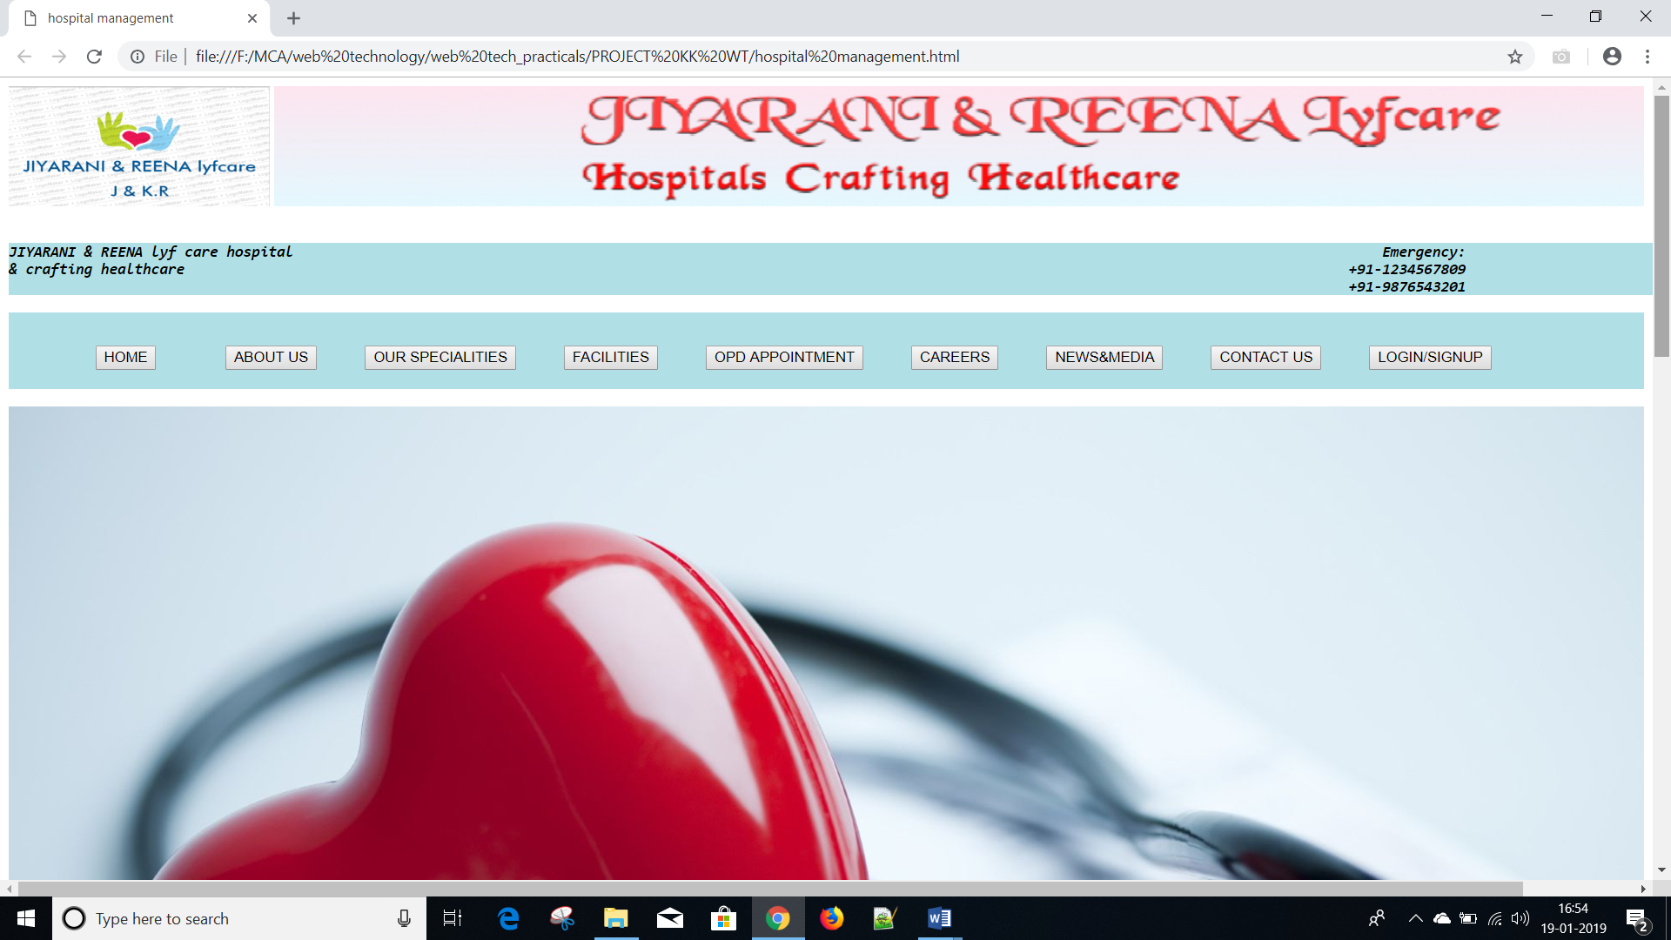

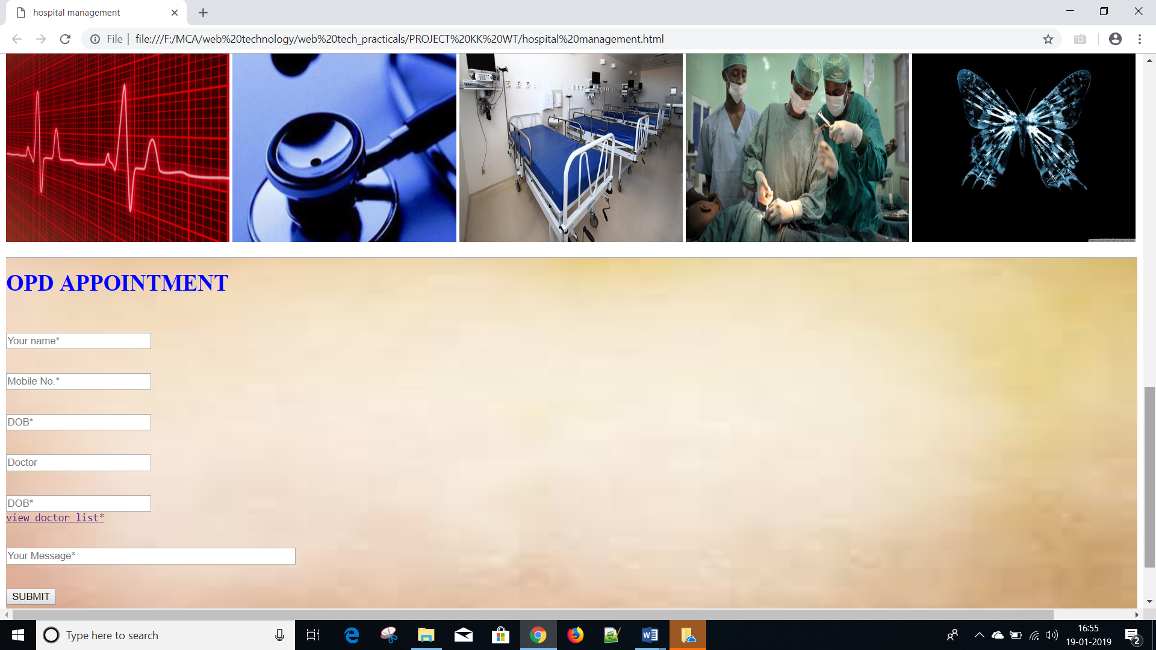

**ABOUT_US**

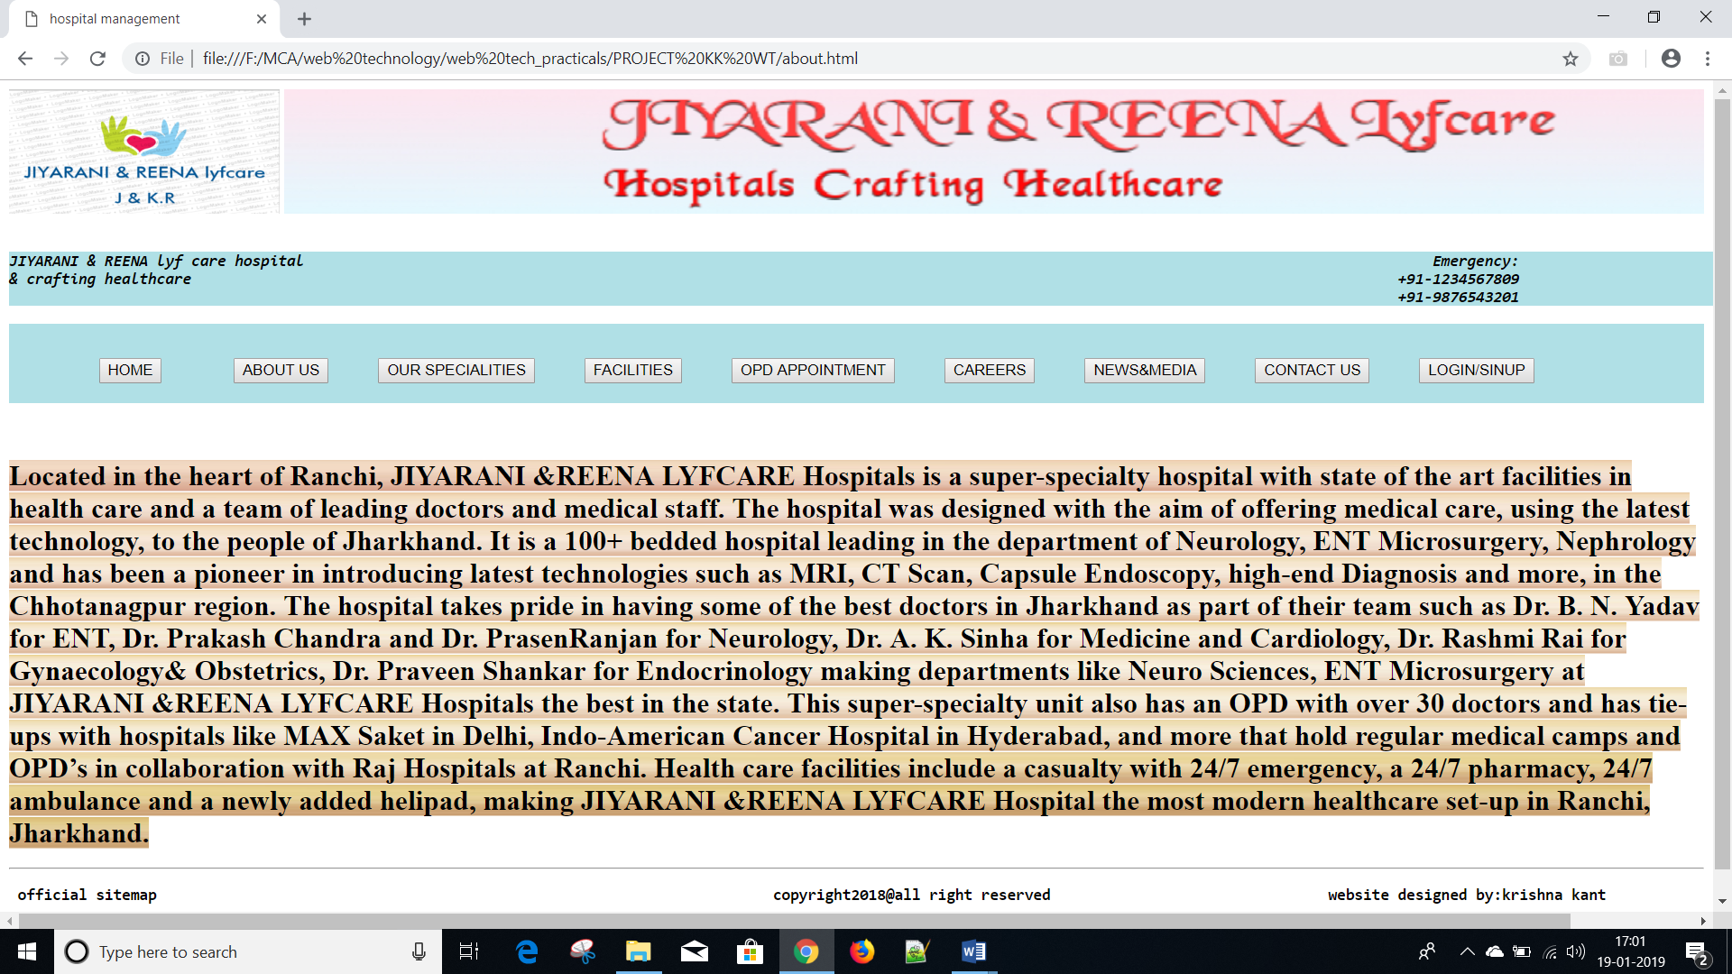

**OUR SPECIALITIES**

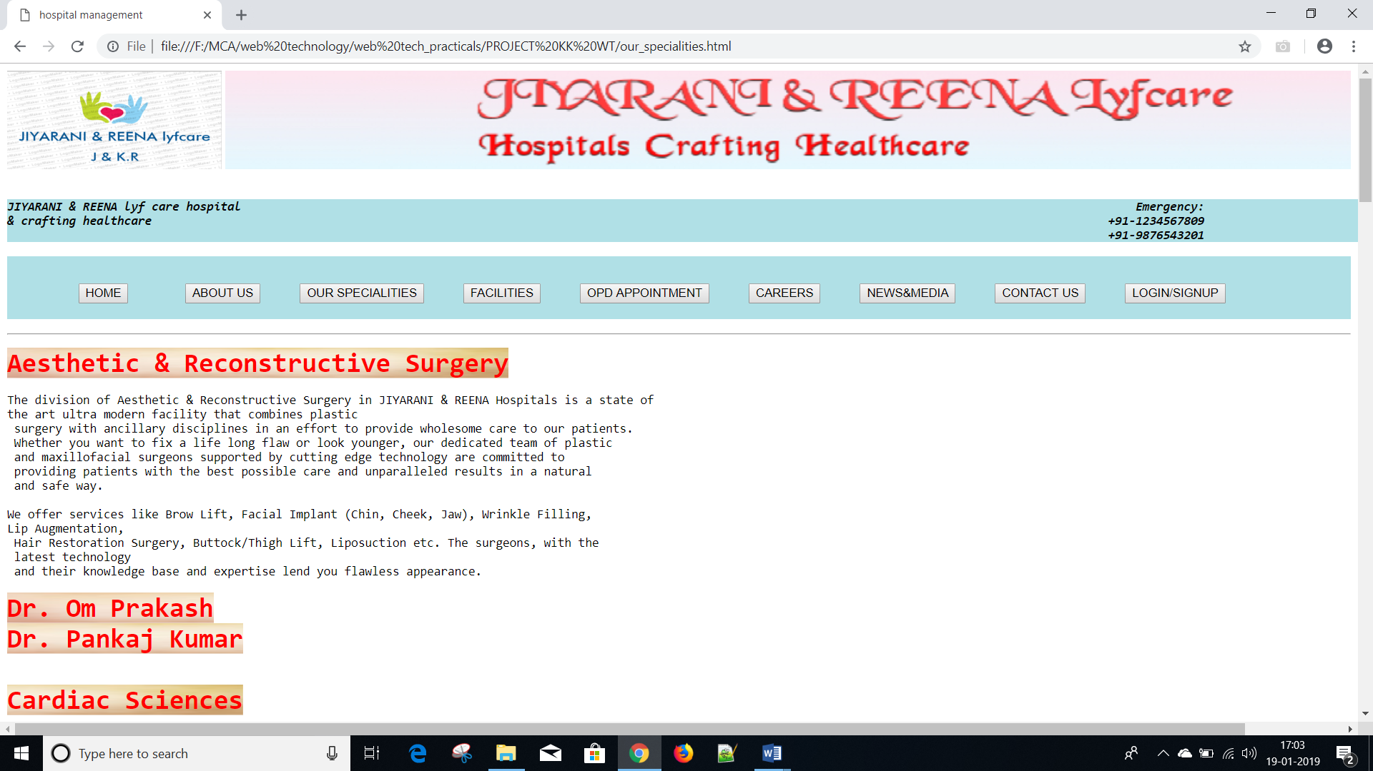



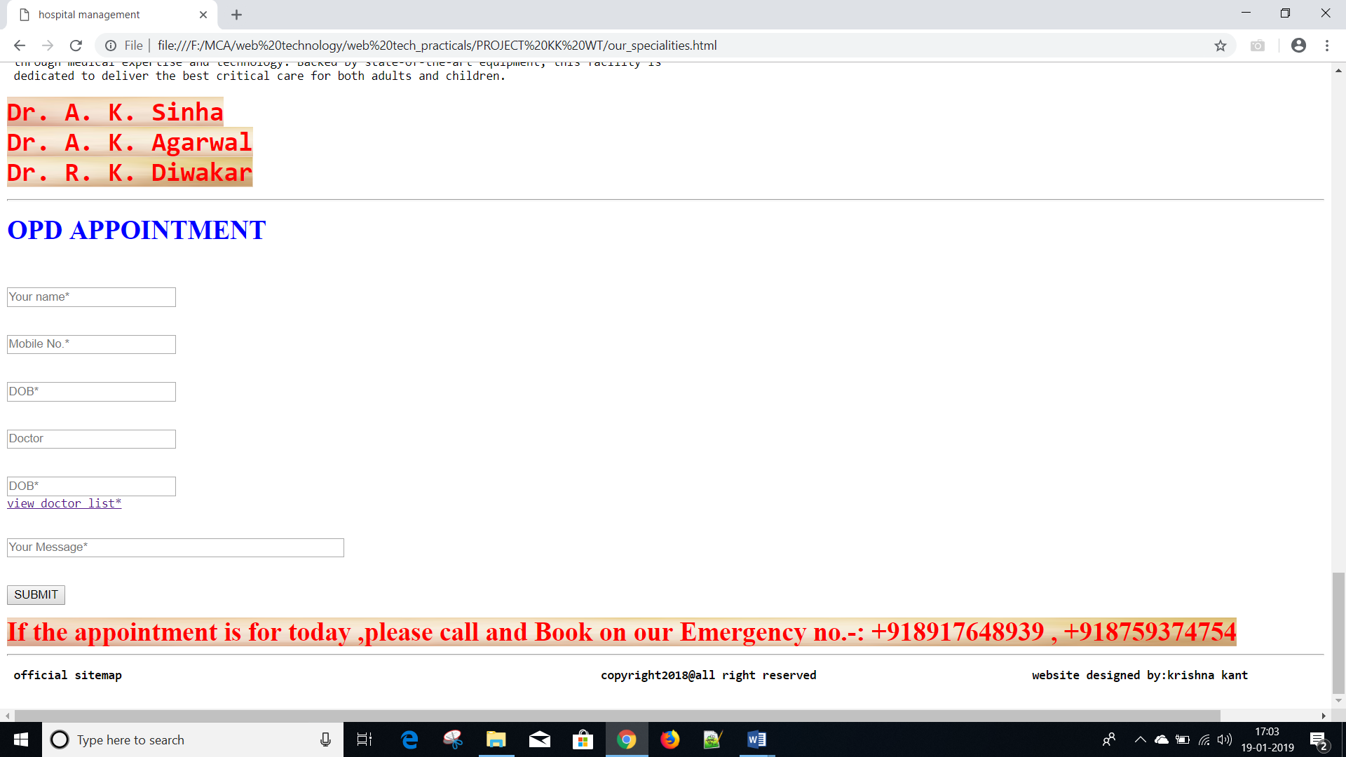

**FACILITIES**

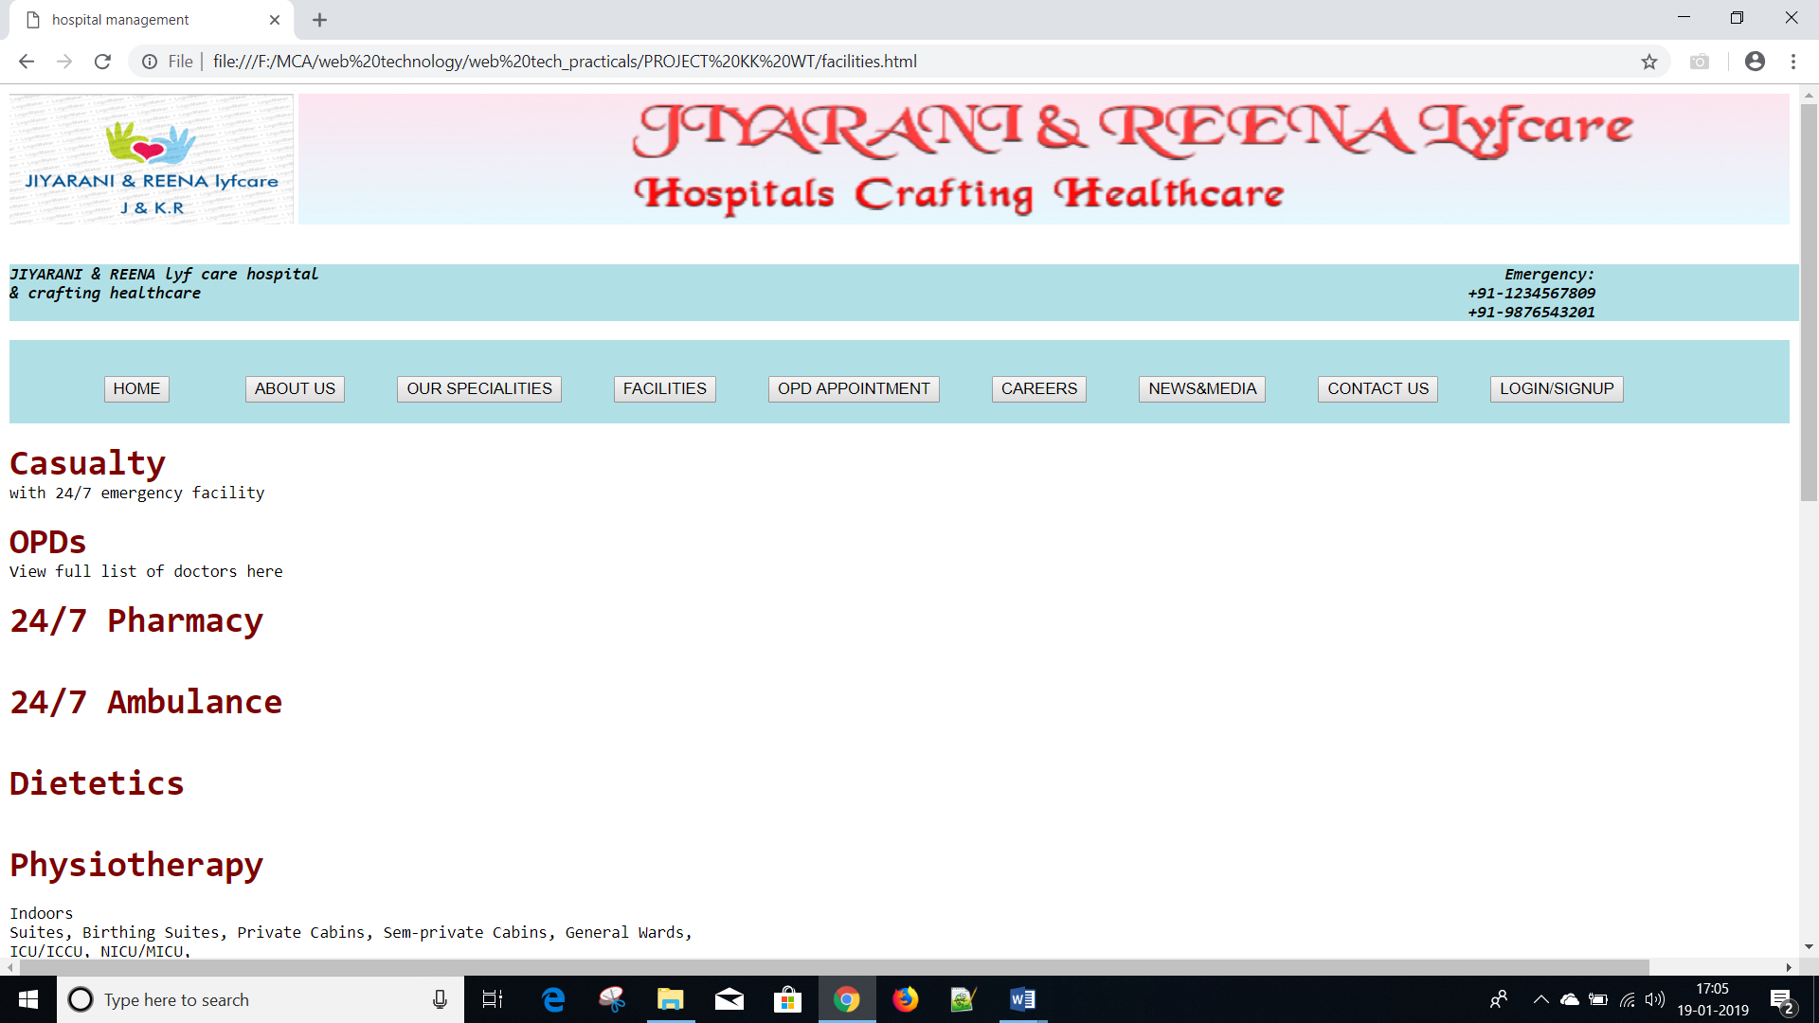

**OPD APPOINTMENT**

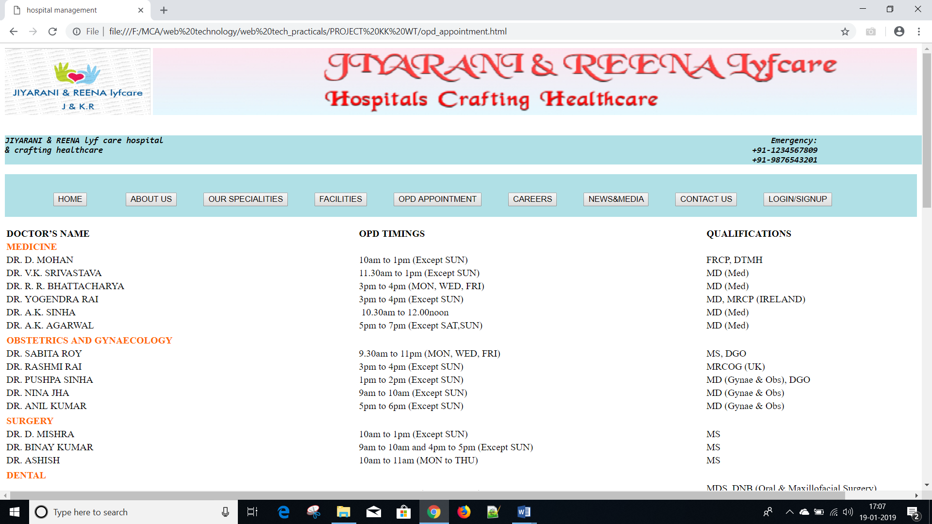

**CAREERS**

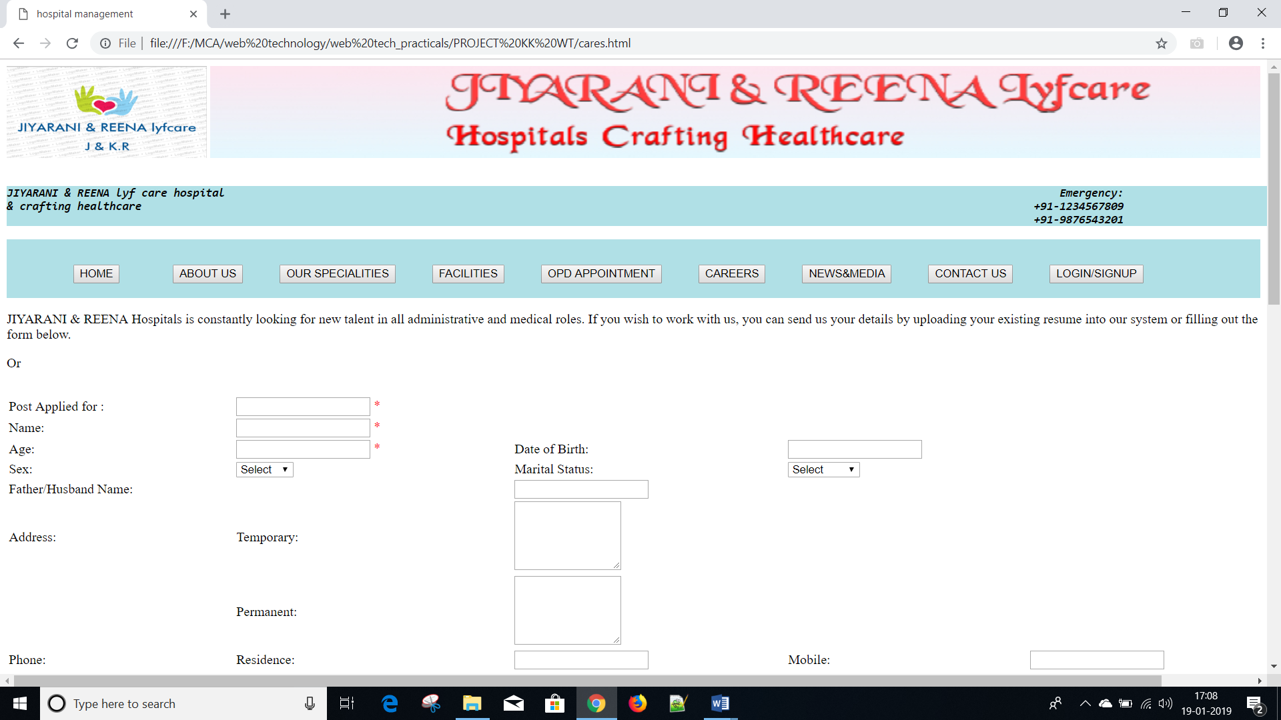

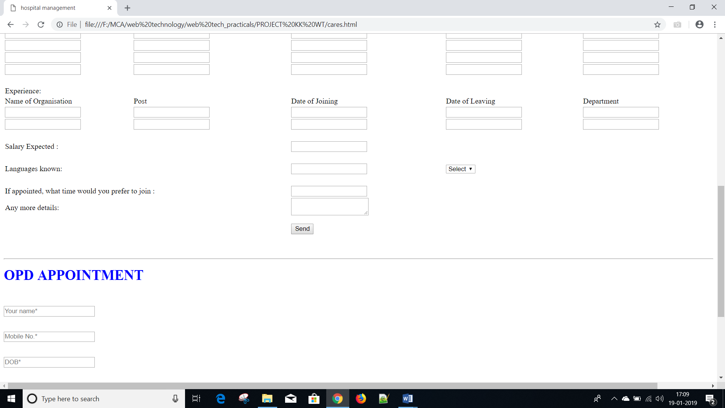

**NEWS AND MEDIA**

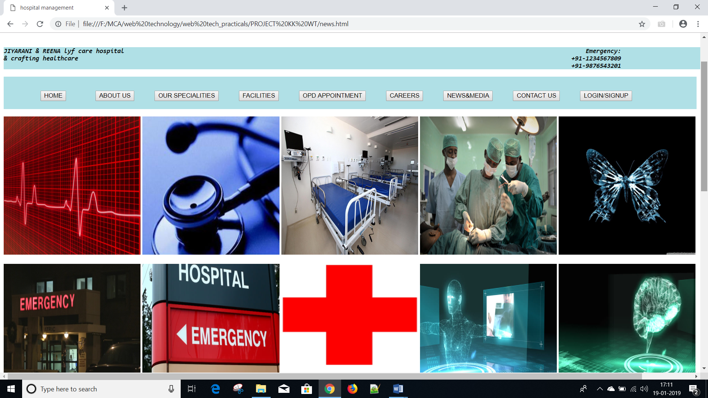

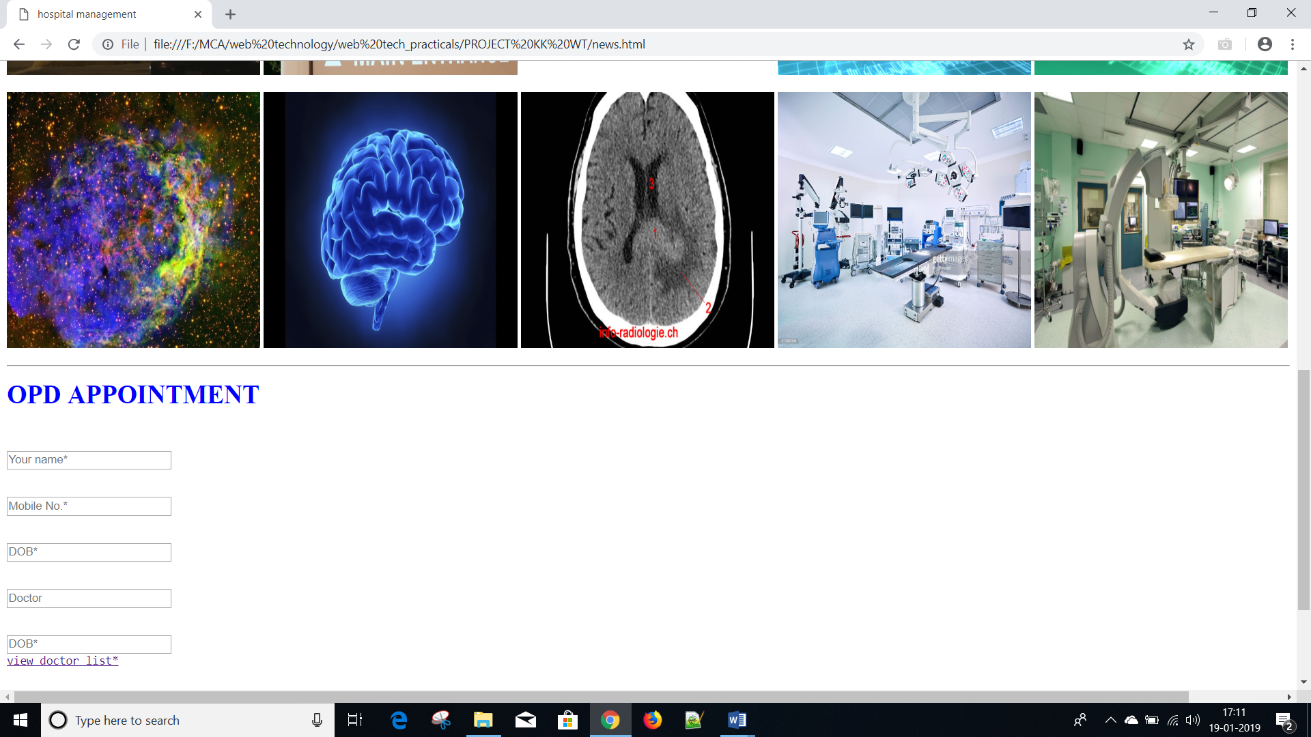

**CONTACT US**

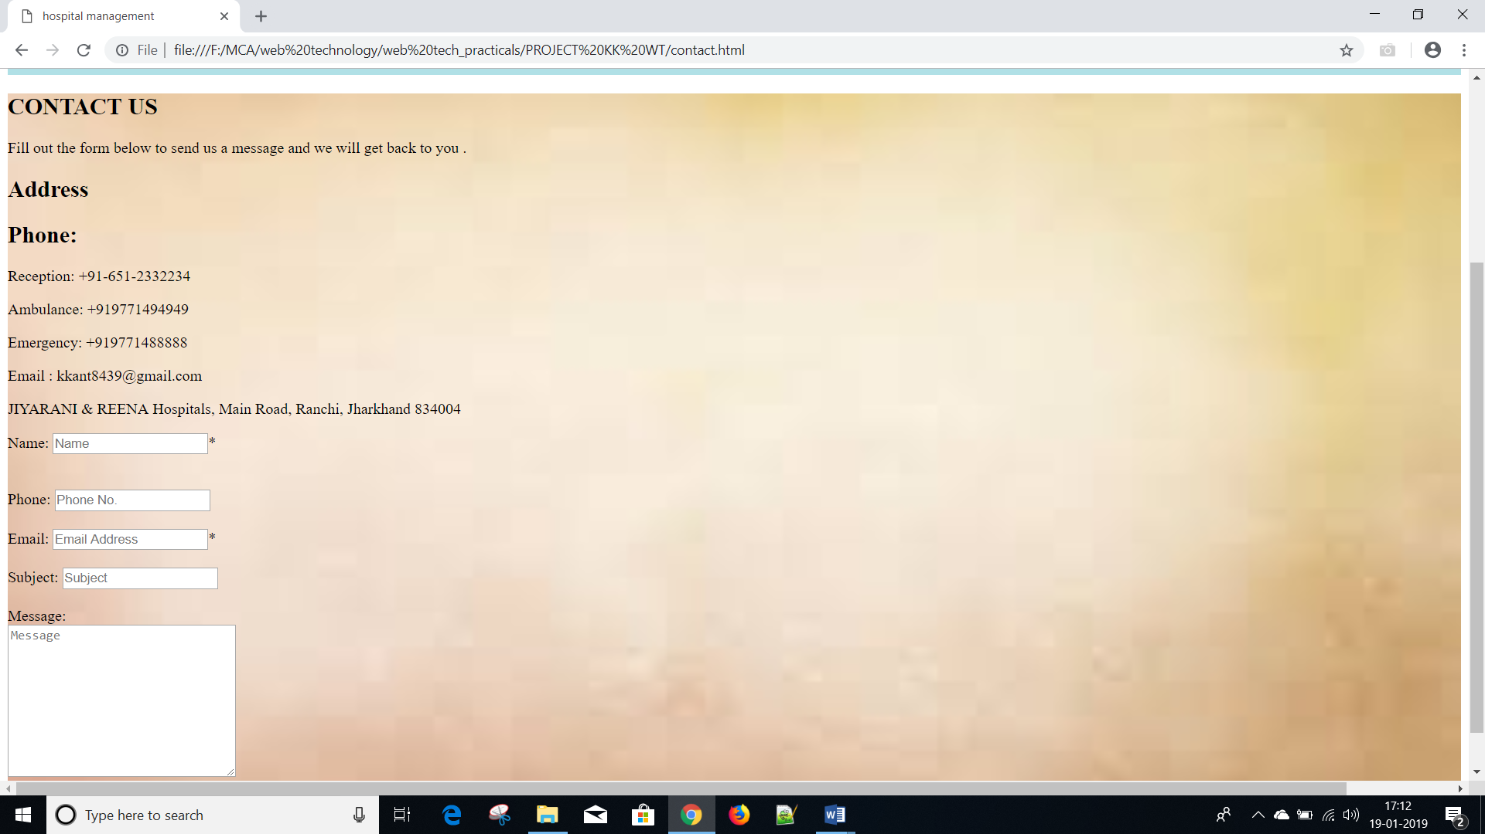

**LOGIN/SIGNUP**

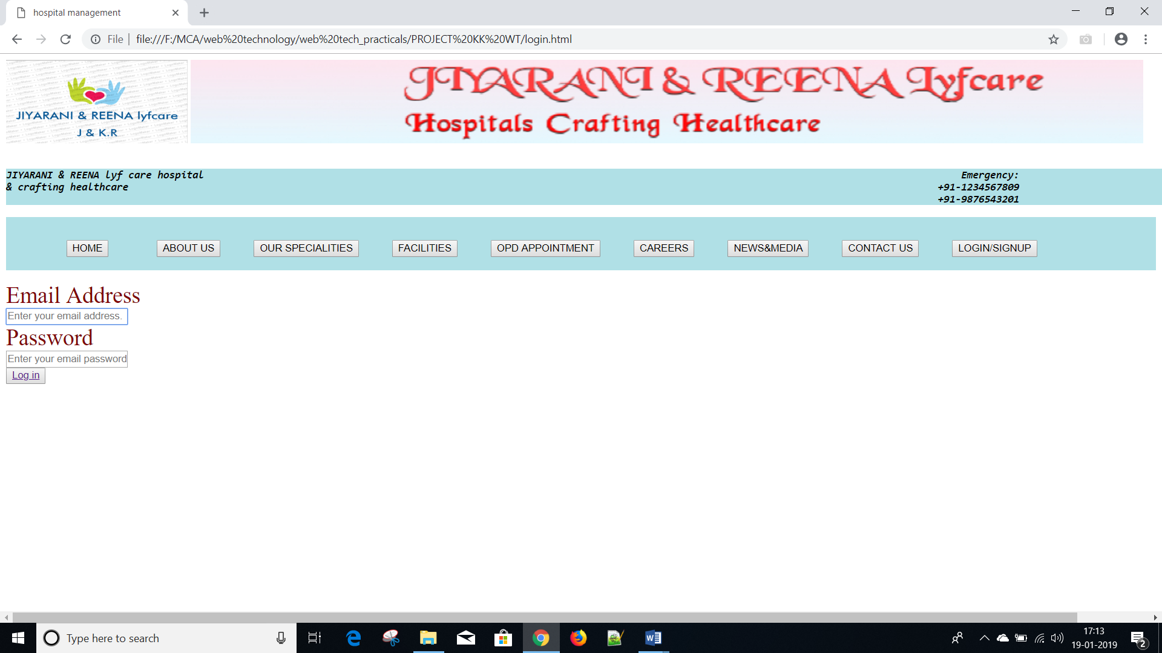

**5.CONCLUSIONS**

 Since we are entering details of the patients electronically in the “HOSPITAL MANAGEMENT SYSTEM”, data will be secured. Using this application, we can retrieve patient’s history with a single click. Thus, processing information will be faster. It accurate maintenance of Patient details. It easily reduces the book keeping task and thus reduces the human effort and increases accuracy speed.

**6.BIBLIOGRAPHY**

(i.) Prof. Shreetha Bhat

(ii.) Prof. Revina Rebecca

(iii) [www.youtube.com](http://www.youtube.com)

(iv) [www.w3schools.com](http://www.w3schools.com)

(v)Mukesh Kumar

(vi) Book- HTML by Robert Sebesta

(vii) Kumar Abhishek

(viii)Pradeep Kumar